# Outline

This document is an induction of how to connect your local SVN client to GitHub version control for Fire Severity App Project. There are two different client for version control, *TourtoiseSVN* and *Git Client in Eclipse*. As we are using GitHub as version control server, we might change our version control into Git and TourtoiseGit instead of subversion and TourtoiseSVN. But the majority concept about version control will be the same, also you can find a lots of tutorials from blog or Youtube.

1. **First Step to use version control is to *Sign up* an account on** [**GitHub**](https://github.com/signup/free)**.**
2. **Visit** <https://github.com/ling250401/> **to see our Project Depository**
3. **GitHub Depository URI:**

Document → https://github.com/ling250401/FireSeverityAppDoc.git

Source Code → <https://github.com/ling250401/FireSeverityAppProject.git>

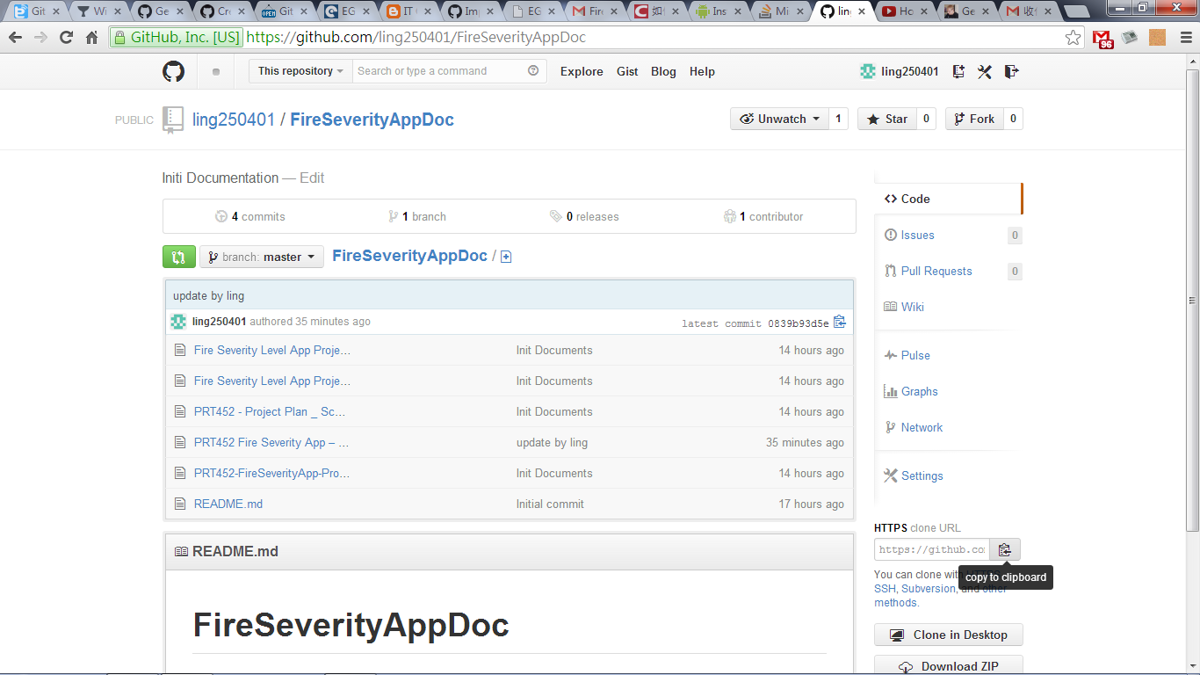

**Also you can copy URL at here**

1. **When you ready to install Git, please see** [Getting Started With Git and TortoiseGit on Windows](http://robertgreiner.com/2010/02/getting-started-with-git-and-tortoisegit-on-windows/)

# TourtoiseSVN

After install **TortoriseSVN**, you are able to *SVN Checkout* under the folder you would like to keep local document.

Please note that, the folder that checkout from GitHub may have problem to commit, please set up TourtoiseGit and Git. It can be more easy to use, we will change our version control by using Git.

1. **Right click → SVN Checkout**

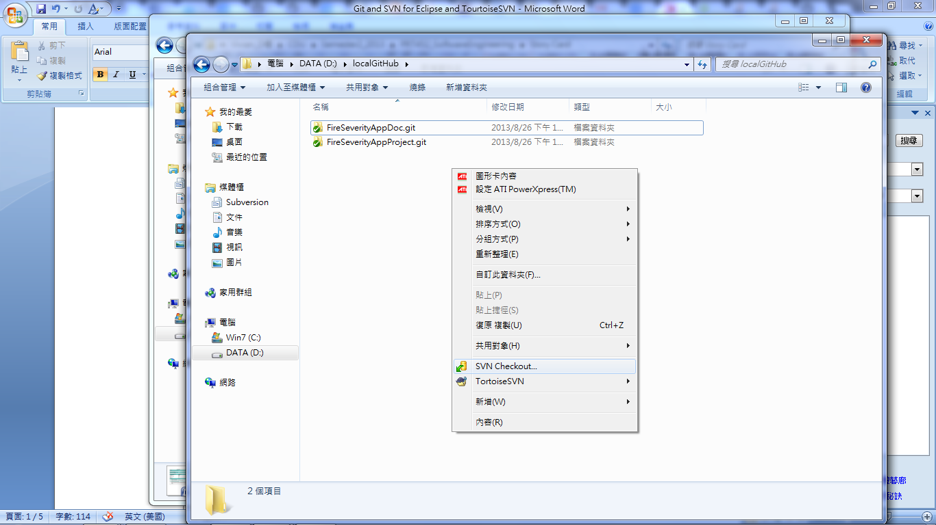

1. **URL of Repository**

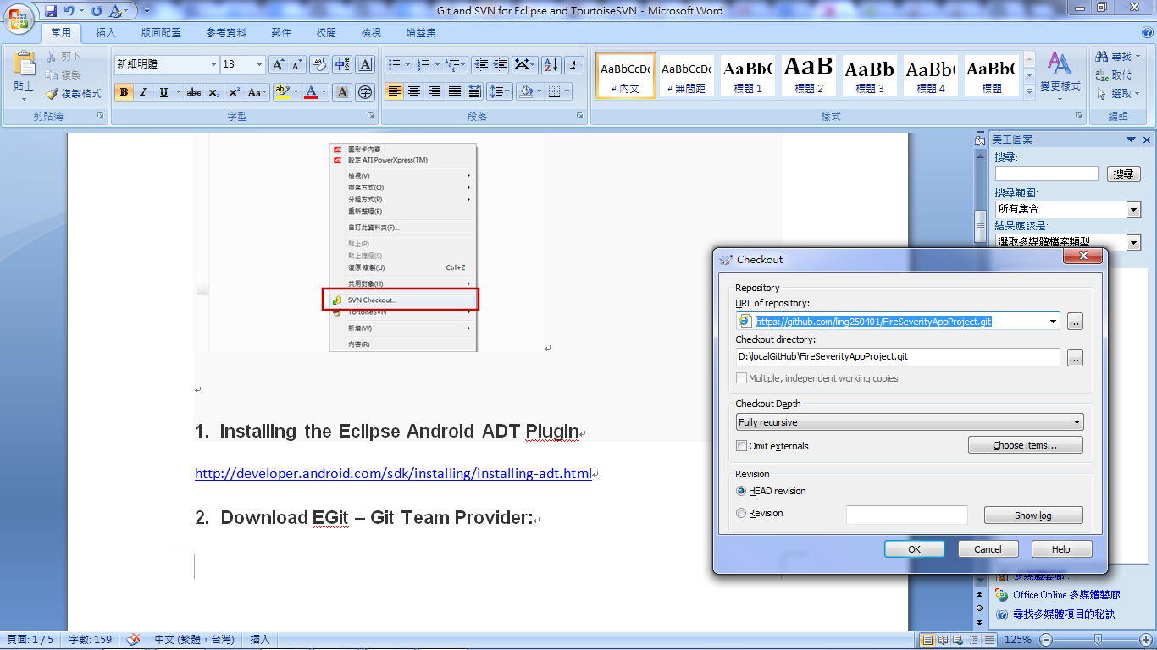

Document → https://github.com/ling250401/FireSeverityAppDoc.git

Source Code → https://github.com/ling250401/FireSeverityAppProject.git

(May need to type in username and password, which is your GitHub account)

1. **Please always keep a copy of your work at your local folder.**

# Import Project from Eclipse, GitHub depository

As our project is Android application in Eclipse environment, please install Eclipse Android ADT Plugin before Import init project from GitHub.

1. **Installing the Eclipse Android ADT Plugin**

<http://developer.android.com/sdk/installing/installing-adt.html>

1. **Download EGit – Git Team Provider:**

Eclipse → Help → Marketplace → Find: EGit

1. **Import Project from Git**

Eclipse → File → Import → Git → Project from Git

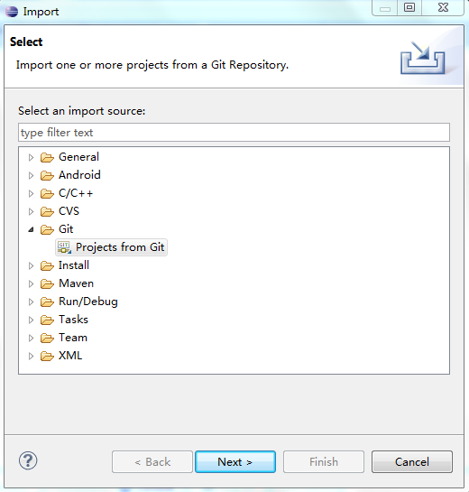

1. **Choose URI source**

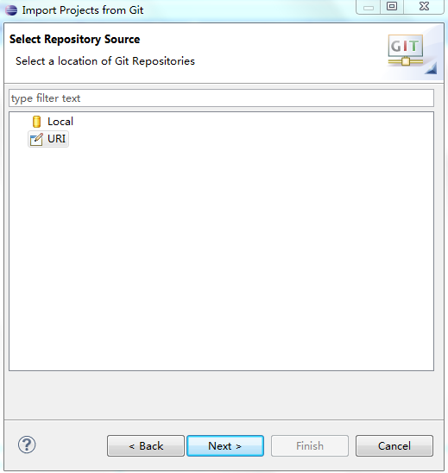

1. **Copy URI:** https://github.com/ling250401/FireSeverityAppProject.git

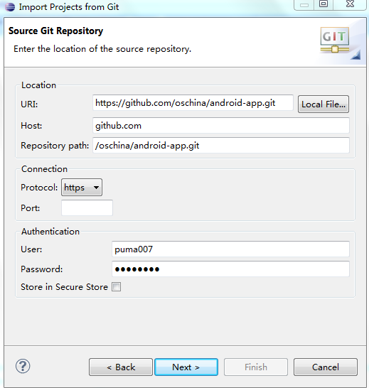

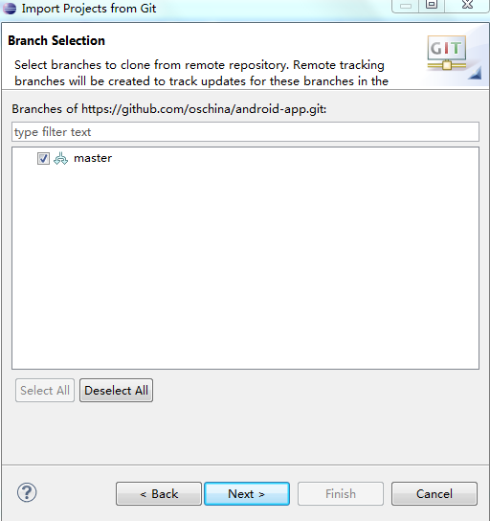

1. Select master branch.

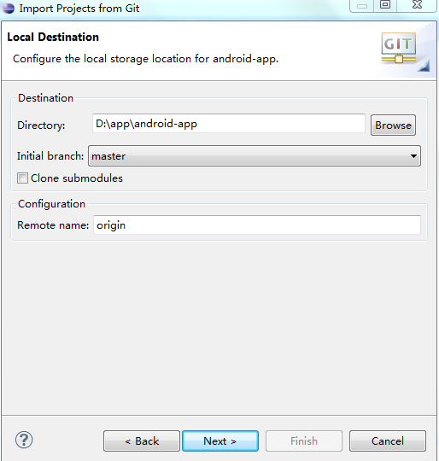

1. Import existing Project

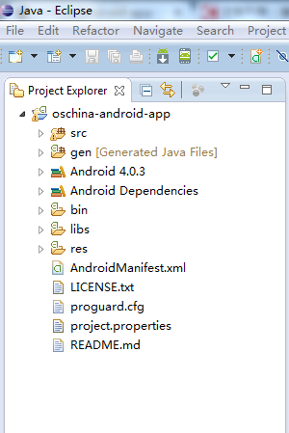

1. Run As an Android Application, you can see **Hello World** in your device.